Federal Electronics Challenge (FEC)
Executive Order 13423
Strengthening Federal environmental, Energy and Transportation Management

The new Executive Order requires Federal agencies to lead by example in advancing the nation’s energy security and environmental performance by achieving these goals:

ELECTRONICS MANAGEMENT: Annually, 95% of electronic products purchased must meet Electronic Product Environmental Assessment Tool (EPEAT) standards where applicable; enable Energy Star features on 100% of computers and monitors; and reuse, donate, sell or recycle 100% of electronic products using environmentally sound management practices.

What is EPEAT?

Electronic Product Environmental Assessment Tool

EPEAT is a system to help purchasers in the public and private sectors evaluate, compare and select desktop computers, notebooks and monitors based on their environmental attributes. EPEAT also provides a clear and consistent set of performance criteria for the design of products, and provides an opportunity for manufacturers to secure market recognition for efforts to reduce the environmental impact of its products.

Located at

http://www.epeat.net

Why must we use EPEAT?

Executive Order No. 13423 was signed by the President on January 24, 2007 and incorporated into FRA prime contract in 2008.

What does the Executive Order State?

Fermilab must purchase, track and report on EPEAT certified equipment in the following three (3) categories;

desktops, laptops and monitors

How will Fermilab achieve this requirement?

It will start with the Director establishing a Policy that requires Divisions/Sections/Centers to meet the requirements in the Executive Order incorporated into FRA’s Prime Contract.

DIRECTOR’S POLICY (DRAFT)

In support of the Federal Electronics Challenge and the requirements of Executive Order 13423, Fermilab has committed to reducing the impact of using personal computers, (including laptops), monitors and printers on the environment. As part of environmentally responsible electronics stewardship, the laboratory will follow the policies and procedures on energy efficient computing found at (link inserted here to CD policy on energy efficient computing).

Personal Computing Environmental Policy

Fermilab is committed to managing the life-cycle of computers in accordance with environmentally sustainable practices. To support this effort, all Fermilab employees, visitors and contractors shall adhere to this policy and the procedures (link) which implement this policy.

Acquisition – Fermilab is committed to meet the prescribed federal acquisition goals for electronic assets by purchasing qualified computing equipment which meets the Electronic Product Environmental Assessment Tool (EPEAT) registration requirements. Requisitioners must provide justification for any acquisitions that are not EPEAT registered. These justifications must be reviewed and approved by line management. Purchases that may cause the failure to meet these goals may be denied.

Utilization – Computing assets will be operated in an energy efficient manner (link to procedure). In particular, procedures define standards for power management of monitors, laptop displays and processing units, and resource utilization standards for printers. Computers that are managed by Fermilab will have these standards automatically applied.

Disposition – Disposal of computing assets will be managed in an environmentally sound manner detailed and coordinated by the Business Services Section Property Management Department.

Forms and Procedure Changes in Oracle Electronic Requisition System to Purchase and Track EPEAT Certified Computer Desktops, Laptops and Monitors

Attachments:

Variance Request Form
Oracle eBS Category List
Purchase Requisition Form

What changes are required to implement this requirement, track EPEAT purchases and report our achievement?

- Changes to the electronic requisition system and forms:

- A new category of “Computer Monitor” in the electronic requisition system has been created to separately track monitors as a category.

- A new category for “Computer Server” in the electronic requisition system has been created to distinguish these systems which will not be tracked at this time but may be in the future.

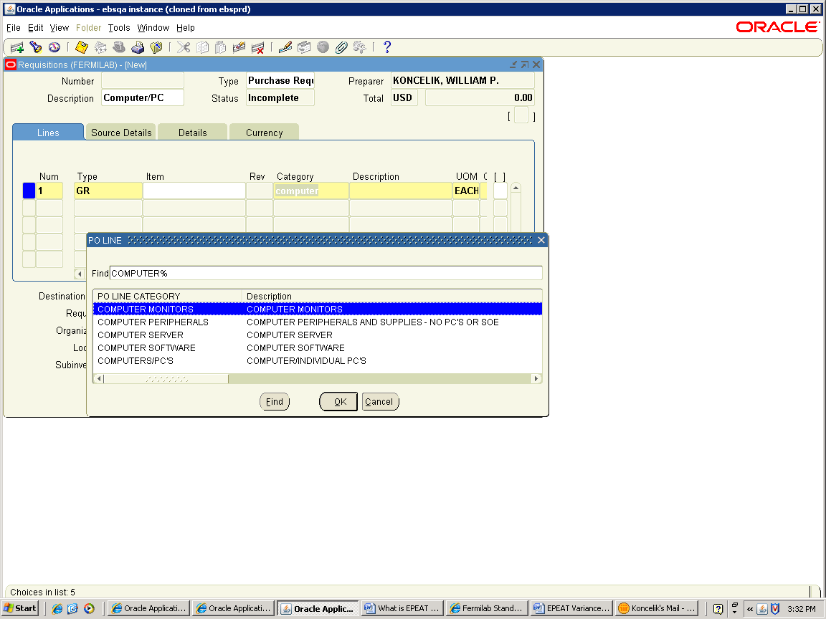

2) Changes to the electronic requisition system and forms:

- Two new flexfields have been created on the requisition line which are required fields if the requisition line has a category of Computers/PC’s or Computer Monitor.

Flexfield 1 Name: COMPUTER OR MONITOR

Choice – Desktop, Laptop, Monitor or Server

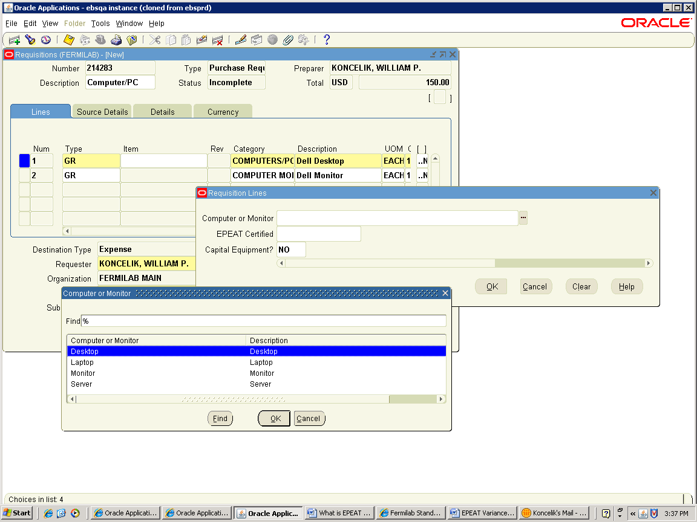

Flexfield 2 Name: EPEAT Certified

Choice – No, Unknown or Yes

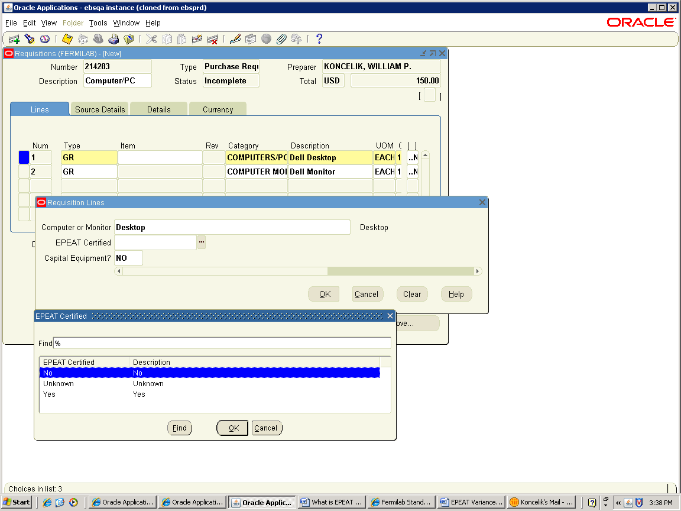

Why are these flexfields being added?

To certify a laptop, desktop or monitor the requester wants procurement to purchase is EPEAT certified or not. Also, these flexfields are being added to track and report in accordance with executive order.

- Change in the way monitors are requisitioned.

- All monitors must be included on a separate requisition line item by itself. Monitors can no longer be included in a desktop bundle. If it is included in the price of a bundled system, you are required to create a separate $00.00 requisition line for the monitor.

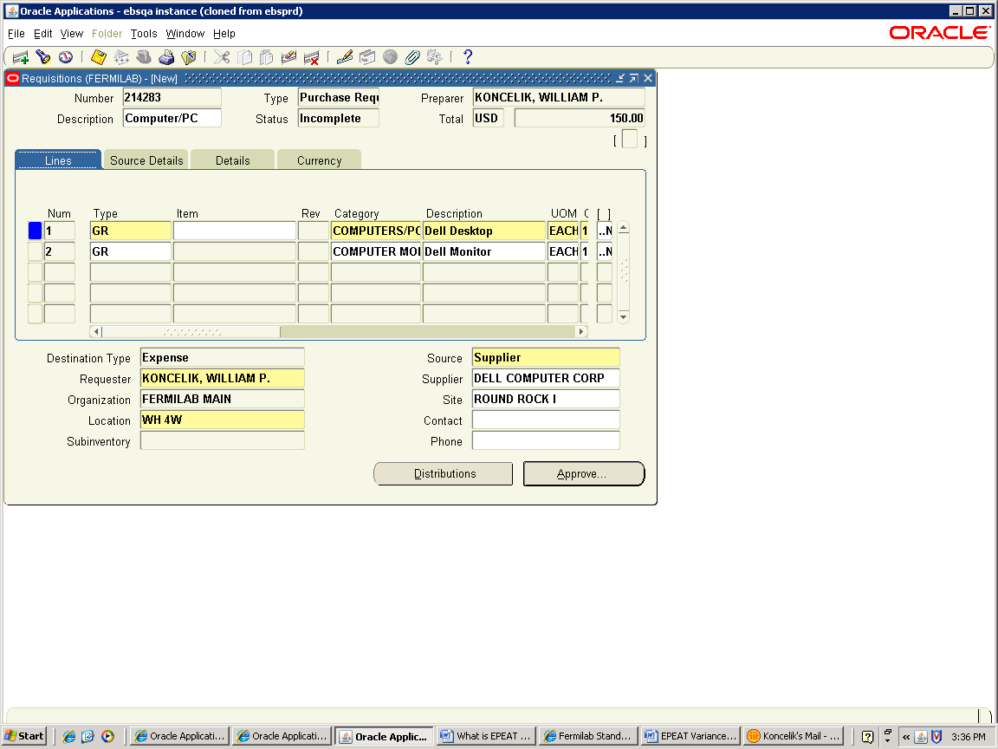

How will a requester confirm a product is EPEAT Certified?

- By checking the EPEAT website at http://www.epeat.net

- By going to the Computing Division Web Page which has a link to both Dell and Apple EPEAT certified systems - http://computing.fnal.gov/xms/Services/Getting_Services/Fermilab_Standard_Computers

- By going to the manufacturer website to see if the system is EPEAT certified.

- Request help from the PC Manager in your Division/Section who will help determine EPEAT status.

If the system or monitor is not EPEAT Certified, what should be done?

- Choose another EPEAT certified desktop, laptop or monitor that meets your requirements.

Or

- The requester must complete an EPEAT Variance Request Form which requires Division/Section approval to purchase a non-EPEAT certified desktop, laptop or monitor. The form is attached to this procedure.

The Variance Request Form is included as a template that can be filled out as an attachment to the Oracle EBs requisition form. The template name is “EPEAT VARIANCE REQUEST FORM”. The template should be attached to the requisition header.

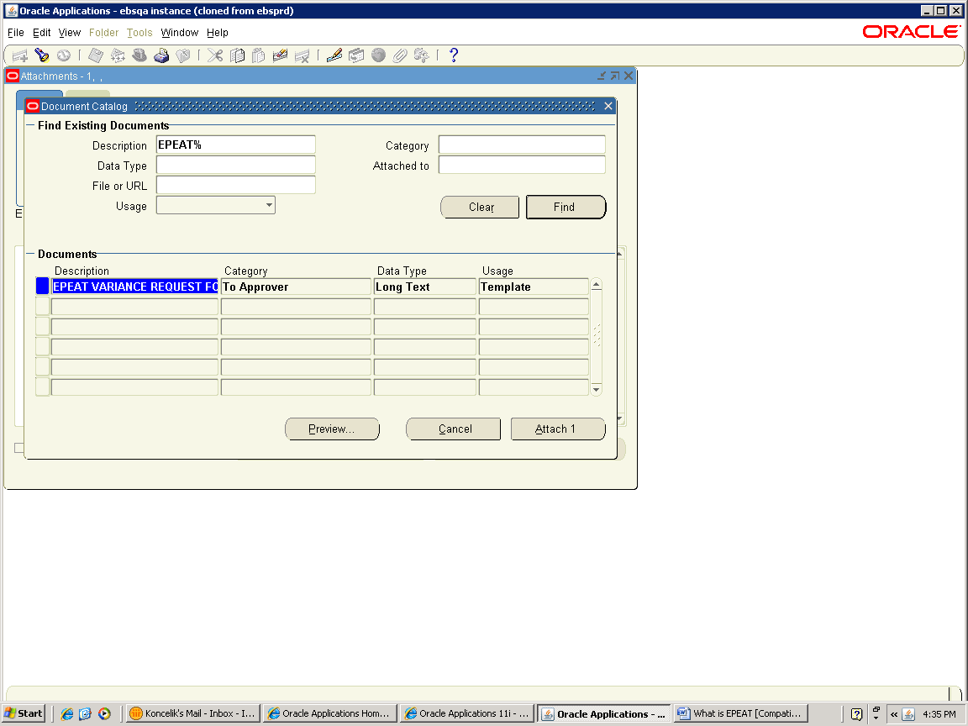

This form is also located on the Business Services Section – Procurement Web Page.

What if a requester cannot determine a system or monitor is EPEAT certified after taking the above actions?

- Choose “Unknown” in the 2nd flexfield on the requisition line and process the requisition as normal.

- Procurement will determine if Desktop, Laptop or Monitor is EPEAT certified and code the PO Line accordingly. If it is not EPEAT certified, procurement will request an approved EPEAT Variance Request form before placing a purchase order for the product.

Variance Request Form
(for laptop, desktop, and monitor acquisitions)

The purpose of this Variance Request Form is to state and justify a request for a laptop, desktop or monitor that does not comply with FEC/EPEAT power usage requirements.

This form must be completed and submitted with the requisition in order to obtain Division/Section/Office/Center Head approval of the purchase.

Requisition Number: Dated:

Name of requester: Extension:

Fit for Use Justification:
This section must describe the specific usage requirements that justify a variance from the EPEAT standard. The justification should include specific lab roles, responsibilities and activities that justify the specific need.

Type your justification here (i.e. “I require a CAD workstation that is outside the standards posted because my job requires me to run 3D modeling simulations.”).

Configuration Specifics:
Please describe the specific or minimum configuration you require.
(e.g. “I would like to add a 9 cell battery to laptop configuration F” or “Apple Macbook Air, 1.8Ghz, 2GB Memory, 128GB Solid-state drive.”)

____________________ ________________________ Date_________
(Supervisor) (Signature)

____________________ ________________________ Date_________
(Division/Section Head) (Signature)

Rev. 1/2010

 |  |  |  | 2008 RESULTS
 | Gold | Silver | Bronze | Non EPEAT | Total | % Certified | % Not certified
Desktops | 244 | 14 | 0 | 94 | 352 | 73.30% | 26.70%
Laptops | 63 | 102 | 0 | 106 | 271 | 60.89% | 39.11%
Grand Total | 307 | 116 | 0 | 200 | 623 | 67.90% | 32.10%
 |  |  |  | 2009 RESULTS
 | Gold | Silver | Bronze | Non EPEAT | Total | % Certified | % Not certified
Desktops | 258 | 3 | 0 | 30 | 291 | 89.69% | 10.31%
Laptops | 242 | 63 | 4 | 14 | 323 | 95.67% | 4.33%
Monitors | 81 | 318 | 0 | 60 | 459 | 86.93% | 13.07%
Grand Total | 581 | 384 | 4 | 104 | 1073 | 90.31% | 9.69%
 |  |  |  | 2010 RESULTS
 | Gold | Silver | Bronze | Non EPEAT | Total | % Certified | % Not certified
Desktops | 451 | 2 | 0 | 25 | 478 | 94.77% | 5.23%
Laptops | 359 | 45 | 0 | 3 | 407 | 99.26% | 0.74%
Monitors | 438 | 126 | 0 | 32 | 596 | 94.63% | 5.37%
Grand Total | 1248 | 173 | 0 | 60 | 1481 | 95.95% | 4.05%

